TO A BLOODY PULP

A SAVAGE WORLDS CAMPAIGN

GOTHAM CITY, 1934

GEAR CATALOGUE

EVERYTHING BUT GUNS

DRAFT #2

By David Nelson
TO A BLOODY PULP OTHER GEAR CATALOGE

Encumbrance: number of encumbrance factors for load-carrying purposes
Armor: the bonus to Toughness for all attacks
Armor vs. Bullets: if the armor provides better protection vs. bullets, use this level instead.
Coverage: part of the body covered by the armor (helmets provide protection vs. head shots 50% of the time.
Material: what the item is made off (for reference)
Range: range that item can be thrown
Area of Effect: explosive template used when activated
Damage: Damage dice rolled on activation
AP: the number of armor points negated before damage is applied
HW: weapon can attack armored vehicles

STANDARD ITEMS:

Each player can be assumed to have whatever clothes they need at home. If not declared otherwise, assume the character is wearing a suit, tie, hat and dress shoes (or a dress, hat, handbag and dress shoes)

Each player will be assumed to have 20-80 dollars, a pack of matches and 1-2 packs of smokes, and a small notebook and pen/pencil.

SECTION 1: ARMOR AND PROTECTIVE DEVICES

Bullet Proof Vest (quality)  Encumbrance 10  Armor: +2  Armor vs. Bullets: +4  Coverage: Torso  Material: silk (expensive)  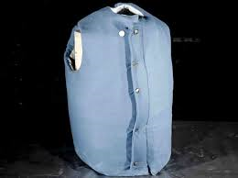 | Flak Jacket (military)  Encumbrance 15  Armor: +2  Armor vs. Bullets: +4  Coverage: Torso  Material: Canvas and Steel plates  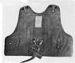
Steel Armor (German)  Encumbrance 20  Armor: +3  Armor vs. Bullets: +4  Coverage: Torso  Material: steel  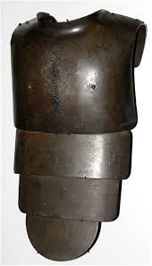 | Steel Helmet  Encumbrance 5  Armor: +4  Coverage: Head (50%)  Material: steel  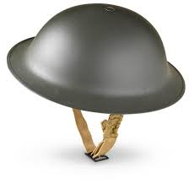

Brewster Body Shield  Encumbrance 40  Armor: +6  Coverage: Torso and Head  Material: steel  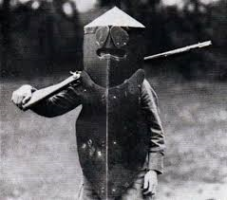 | Bullet Proof Vest (ordinary)  Encumbrance 12  Armor: +1  Armor vs. Bullets: +3  Coverage: Torso  Material: canvas, cotton  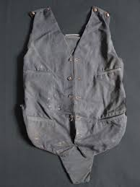
Gas Mask  Encumbrance 2  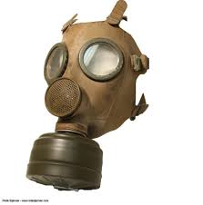 | Fire Proof Suit  Encumbrance 10  Armor: +6 vs. Fire attacks only  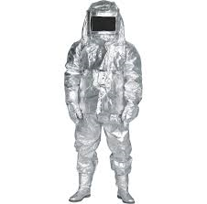
SECTION TWO: GRENADES, EXPLOSIVES, AND SPECIAL WEAPONS

Hand Grenade (US)  Encumbrance 2  Range: 5/10/20  Area of Effect: Medium Burst  Damage: 3d6  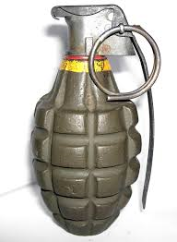 | Potato Masher Grenade (Ger)  Encumbrance 2  Range: 5/10/20  Area of Effect: Medium Burst  Damage: 3d6-2  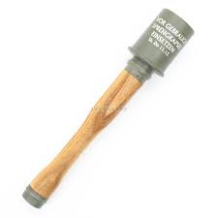
M10 Anti-tank Grenade (US)  Encumbrance 4  Range: 4/8/16  Area of Effect: Small Burst  Damage: 3d6 AP 4 HW  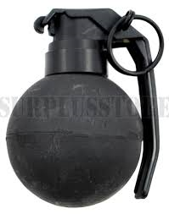 | Satchel Charge  Encumbrance 6  Range: 3/6/12  Area of Effect: Large Burst  Damage: 4d6 HW AP 2  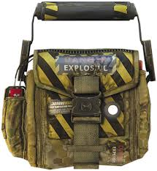

Tear Gas Grenade  Encumbrance 2  Range 5/10/20  Area of Effect: Medium for 3 turns  Effect: targets caught in the gas will suffer -3 for all Agility and Strength related tasks and skills for as long as they remain in the cloud and 1d4 turns after..  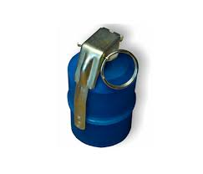 | Fire Crackers  Encumbrance 1  Range 5/10/20  Effect: distraction, induces fear of gunfire among civilians  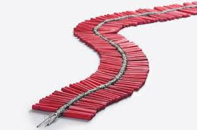
Molotov Cocktail  Encumbrance 2  Range 3/6/12  Damage: check to catch fire  Area of Effect: Medium Burst  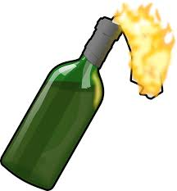 | Smoke Grenade  Encumbrance 2  Range 5/10/20  Area of Effect: Small, then Medium for 3 turns  Effect: targets hidden by smoke are -6 to be hit by Shooting, +2 Parry, effects those looking out, into or through smoke equally.  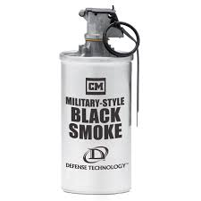

Stick of Dynamite  Encumbrance 2  Range: 4/8/16  Area of Effect: Medium Burst  Damage: 2d6  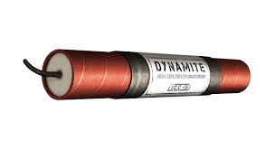 | Bundle of Dynamite  Encumbrance 8  Range: 3/6/12  Area of Effect: Large Burst  Damage: 3d6  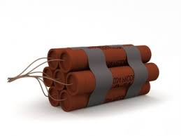
Demolition Kit  Encumbrance 3  Plunger, fuses, blasting caps  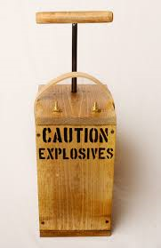  Combine with Knowledge (Demolitions) and the appropriate amount of dynamite for destroying buildings and the like. | Timer  Encumbrance 1  Useful for bombs and other things  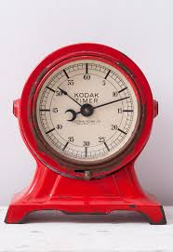

Flame Thrower  Encumbrance 70 Min Str d8  Range: 0  Area of Effect: Cone Template  Damage: 2d10 Ignores Armor  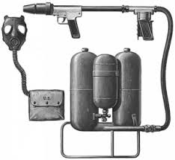 | Sticky Bomb  Encumbrance 6  Range: 4/8/16  Area of Effect: Medium Burst  Damage: 4d6 HW AP 6  On a throw check, sticks to target, and fuse activates for 1d4 turns.  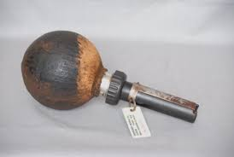
Nerve Gas Grenade (lethal)  Encumbrance 2  Range 5/10/20  Damage: Vigor check or Wound  Area of Effect: Small, then Medium, then Small  Stopped by Gas Mask  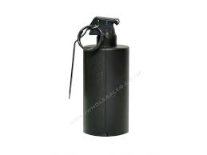 | Nerve Gas Grenade (paralysis)  Encumbrance 2  Range 5/10/20  Damage: Vigor check or unconscious 2d6 minutes  Area of Effect: Small, then Medium, then Small  Stopped by Gas Mask  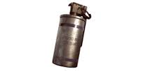

SECTION 3: MELEE WEAPON, BOWS ETC.

Dagger  Encumbrance 1  Range: 3/6/12  Damage: Str+1d4  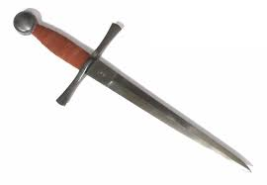 | Cavalry Saber  Encumbrance 4  Damage: Str+1d6  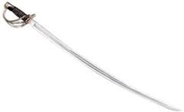
Bayonet  Encumbrance 1+rifle  Damage: Str+1d6  Reach +1, Parry +1, 2-hands  Treat as Dagger if not attached to a rifle  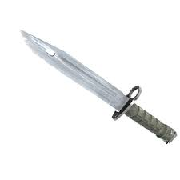 | Katana  Encumbrance 6  Damage: Str+1d6+2 AP 2  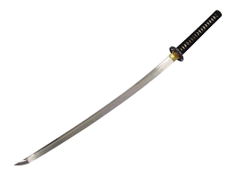

Billy Club  Encumbrance 1  Damage: Str+1d4  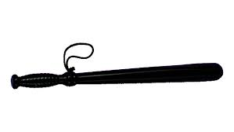 | Brass Knuckles  Encumbrance 1  Damage: Str+1d4  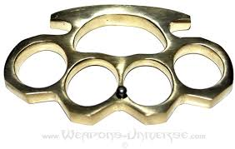
Switchblade  Encumbrance 1  Damage: Str+1d4  -2 to be noticed on a search  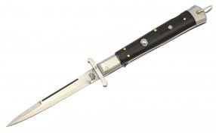 | Sword  Encumbrance 8  Damage: Str+1d8  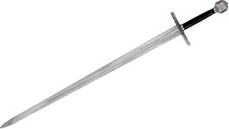

Rapier  Encumbrance 3  Damage: Str+1d4  +1 Parry  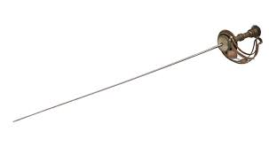 | Spear  Encumbrance 5  Damage: Str+1d6  +1 Parry, +1 Reach, 2-hands  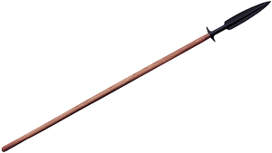
Staff  Encumbrance 8  Damage: Str+1d4  +1 Parry, 2-hands  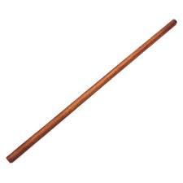 | Bowie Knife  Encumbrance 2  Damage: Str+1d4+1  Cannot be thrown  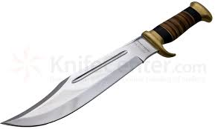

Sword-Cane  Encumbrance 4  Damage: Str+1d4  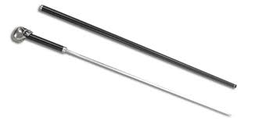 | Hidden Knife-Boot  Encumbrance 1  Damage: Str+1d4  -2 to fighting rolls and parry  Great for helping someone when both are tied up.  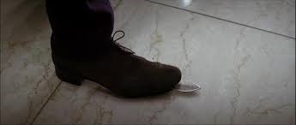
Net  Encumbrance 5  Range 3/6/12  Effect: if hit, roll Str -2 or Agi -2 to free oneself; Success: costs action, Raise: immediate release.  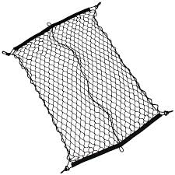 | Whip  Encumbrance 4  Damage: Str+1, Reach 1  Can be used to grapple at 1” range  Can be used to swing up to 4”  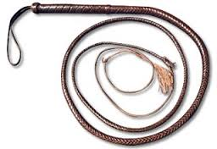

Throwing Star  Encumbrance 1/4  Range: 4/8/16  Damage: Str+1  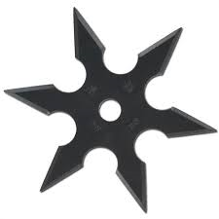 | Bow  Encumbrance 5 (includes 50 arrows)  Range: 12/24/48  Damage: 2d6  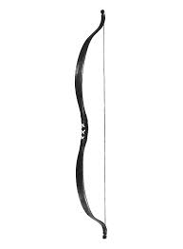
Crossbow  Encumbrance 12 (includes 50 bolts)  Range: 15/30/60  Damage: 2d6 AP 2  1 full action to reload each time  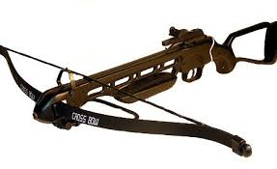 | Blowgun  Encumbrance 2 (includes 25 darts)  Range: 3/6/12  Damage: Str+1d4  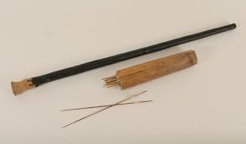

SECTION 4: TOOLS

Shovel  Encumbrance 5  Damage: Str+1d4  2-hands  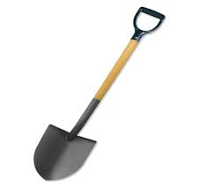 | Crowbar  Encumbrance 2  Damage: Str+1d4  Material: Iron  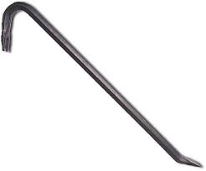
Tire Iron  Encumbrance 2  Damage: Str+1d4  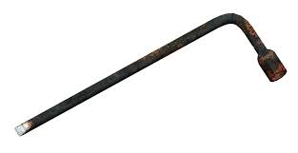 | Ice Pick  Encumbrance 1/2  Damage: Str+1d4  -2 parry, -2 notice during search  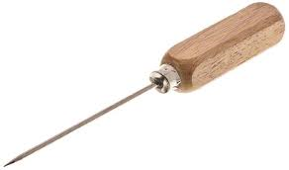

Chainsaw  Encumbrance 25  Damage: 2d6+4  Natural “1” on fighting die means user hits himself, regardless of wild die.  Min Str: 1d8  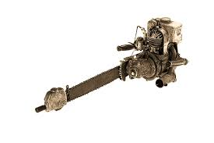 | Mechanic’s Tool Kit  Encumbrance 5  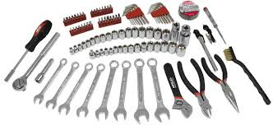
Electrician’s Tool Kit  Encumbrance 5  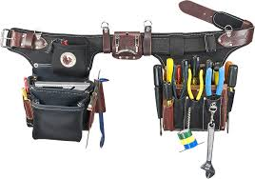 | Hammer  Encumbrance 1  Damage: Str +1d4  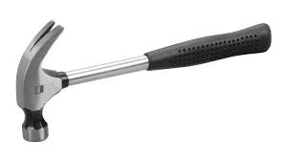

Pick Axe  Encumbrance 10  Damage: Str+1d8  -1 Parry, 2-hands  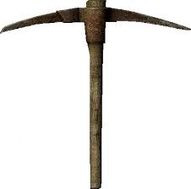 | Axe  Encumbrance 10  Damage: Str+1d8  -1 Parry; 2-hands  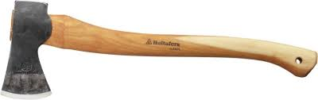
Hatchet  Encumbrance 2  Damage: Str+1d6  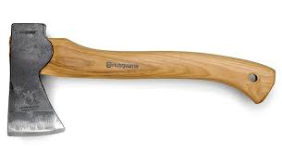 | Sledge Hammer  Encumbrance 15 Min Str 1d6  Damage: Str+1d8  -1 Parry, 2 hands  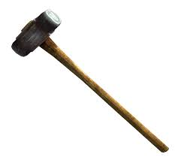

SECTION 5: ADVENTURE GEAR
Grappling Hook  Encumbrance 2  Material: Steel  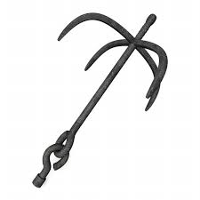 | Lock Picks  Encumbrance 1  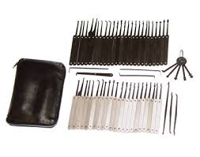
Rope 50’  Encumbrance 15  Material: Hemp  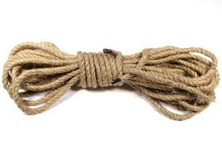 | Silk Rope 50’  Encumbrance 8  Material: silk (expensive)  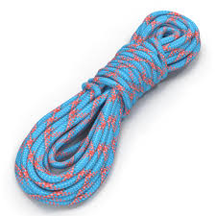

Lantern (4” radius)  Encumbrance 3  Material: Propane  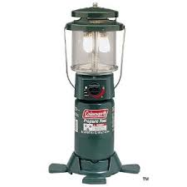 | Flash Light  Encumbrance 3  Damage: Str+1  10” Beam  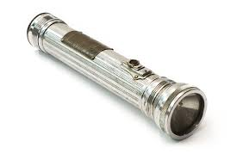
Flare Gun  Encumbrance 4 (includes 6 flares)  Range 12/24/28  Damage: 2d6 Single Shot  Large Burst Illumination  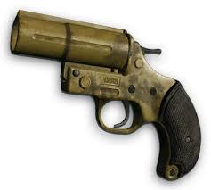 | Handcuffs  Encumbrance 1  Material: steel  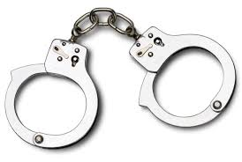

Lineman’s Telephone  Encumbrance 2  Can be used to tap into phone wire  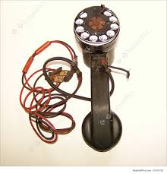 | Magnifying Glass  Encumbrance 1
Camera  Encumbrance 4  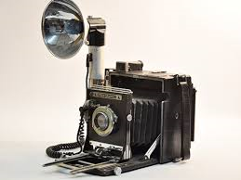 | Binoculars  Encumbrance 2  +3 to Notice Rolls at distance  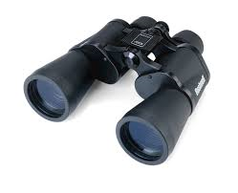

Canteen  Encumbrance 3 (includes 2 pints water)  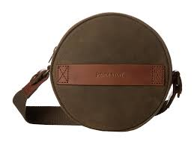 | Backpack  Encumbrance 2  Material: Canvas  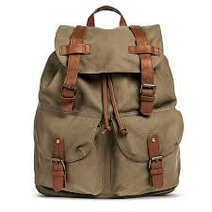
Bedroll  Encumbrance 4  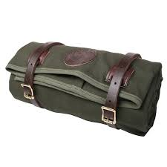 | Parachute  Encumbrance 20  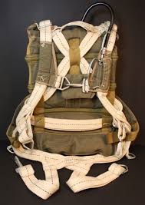

Whistle  Encumbrance 0  Material: steel  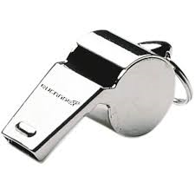 | Disguise Kit  Encumbrance 4  Combined with Streetwise, or an appropriate knowledge skill to make a disguise.  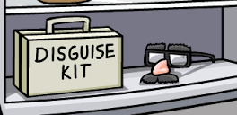
ROAD FLARE  Encumbrance ½  Area of Effect: Large Burst, 10 rounds  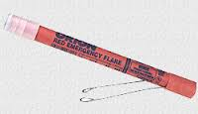 | Gas Can  Encumbrance 42 (full) 2 (empty)  Contains: 5 gallons of gasoline  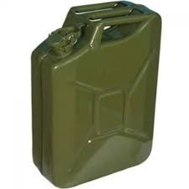

Survival Kit  Encumbrance 5  Effect: +2 bonus to Survival Rolls  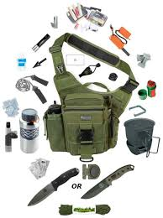 | Swiss Army Knife  Encumbrance 1  Damage: Str  Effect: reduces Repair penalty for not using tools from -2 to -1  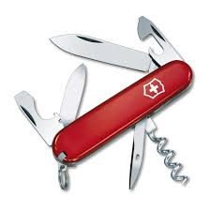
Climbing Gear  Encumbrance 10  +2 to Climbing Checks  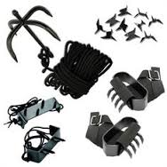 | Inflatable Rubber Raft  Encumbrance 30  Holds: 3 people  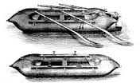

SECTION SIX: PERSONAL GEAR

Umbrella  Encumbrance 2  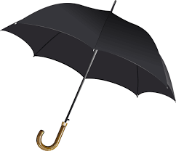 | Lighter  Encumbrance 0  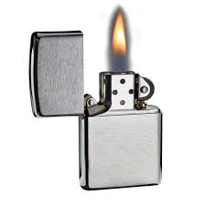
Canvas Bag  Encumbrance 1  Contains: up to 50 Encumbrance of stuff  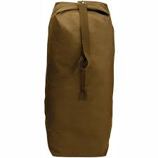 | Steamer Trunk  Encumbrance 10  Contains: up to 40 Enc of stuff  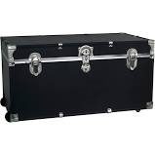

Brief Case  Encumbrance 2  Contains: up to 10 Enc of flat stuff  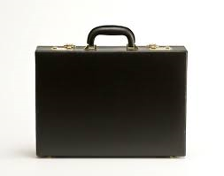 | Suit Case  Encumbrance 4  Contains: up to 20 Enc of stuff  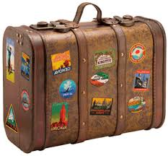
Metal Flask  Encumbrance 1  Material: steel  Holds 1 pint  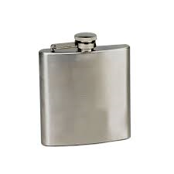 | Bottle of Good Bourbon  Encumbrance 3  Material: Glass  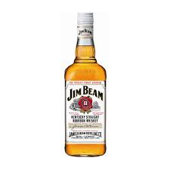

Dapper Dan Pomade (or FOP)  Encumbrance 0 | Awesome Pocket Watch  Encumbrance 0  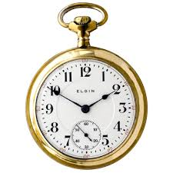
Box of Good Cigars  Encumbrance 2  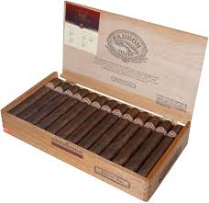 | Fancy Box of Toothpicks  Encumbrance 0  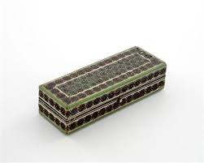

Bible  Encumbrance 2  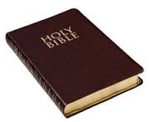 | Tobin’s Spirit Guide  Encumbrance 2  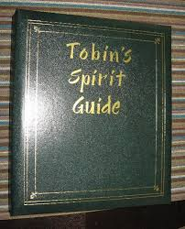
Harmonica  Encumbrance 0  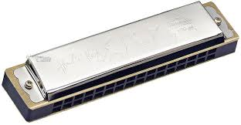 | Deck of Cards  Encumbrance 0  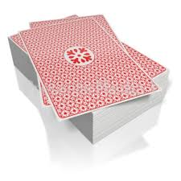

SECTION SEVEN: MEDICAL AND SCIENTIFIC GEAR

Bottle of Cyanide  Encumbrance 1  Damage: Vigor roll every 10 minutes for 1 hour or take a wound, 3rd wound equals death.  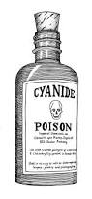 | Bottle of Chloroform  Encumbrance 1  Damage: if soaked rag is held over mouth/nose (grapple attack) for 3 turns (opposed Str to escape), knocks unconscious for 10 minutes, 6 turns equals death  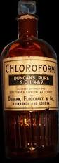
Cyanide Antidote Kit  Encumbrance 3  Successful Healing check stops any further damage from Cyanide poisoning  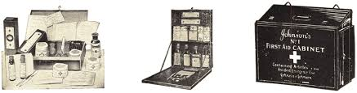 | Anti-venom  Encumbrance 1  Effect: negates poison from 1 attack by scorpion or snake  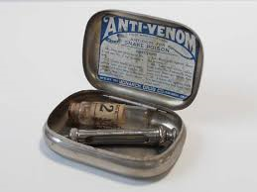

Doctor’s Bag  Encumbrance 6  Required for “Medical Attention” in field  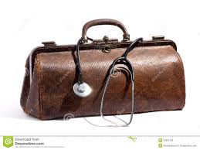 | First Aid Kit  Encumbrance 3  Required to Treat Injuries after battle  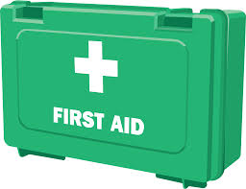
Geiger Counter  Encumbrance 2  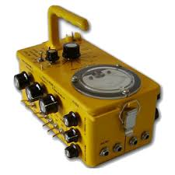 | Chemical Test Kit  Encumbrance 8  