WANTED, PREFERABLY ALIVE,
LAST SEEN IN CROSSROADS TAVERN
Bridgit Mithrilhall  Dwarf archaeologist. She returned certain artifacts to Father Chanceford of Dwergontia, rather than to the Temple of Atlas who owned the site they were found.  Players will get 750xp each if she is returned alive to the Temple of Atlas. Delivery of her corpse yields only 250xp. XP also reduces debt an equivalent amount. | Fang Bungis  Orc mystic. He used some sort of mental force to cheat the Brotherhood of Victory out of a significant amount of money and land in a mercenary deal.  Players will get 500xp each if he is returned alive to Sir Wymer. Delivery of his corpse yields only 350xp. XP also reduces debt an equivalent amount.
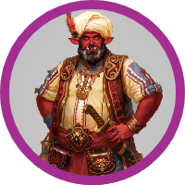  Worgos Suckamungus  Hoborg Merchant: he is a hoborg, isn’t that reason enough? But, he did sell the Brotherhood tainted rations and wine for a long campaign.  Players will get 750xp each if he is returned alive to Sir Wymer. Delivery of his corpse yields only 500xp. XP also reduces debt an equivalent amount | Joe Wanker  Human Thief: he was part of a crew that broke into the Mystic Union, stole a bunch of books and sold them off to Mrow in Passburg.  Players will get 500xp each if he is returned alive to the Mystic Union. Delivery of his corpse yields only 200xp. XP also reduces debt an equivalent amount.

