Session/Game: D&D 4e, Irongate 3 Date: August 3, 2008

EPISODE 3: The Slavers of Onnwal

Campaign Date: July 30 to August 1, year 110 of the 4th Age of Time

Characters:
Smack ‘Em, kobold, warlock-1 (Marlon Kirton)
Fafnir Jalapino, dragonborn, fighter-1 (Joe Cress)
Dirk Fallohide, halfling rogue-1 (Dave Hanley)
Balasar, dragonborn, warlord-1 (Chris)
Athalric, human, warlord-1 (Dave Nelson)
Aramil, Eladrin, ranger-1 (David Combs)
Nurz, half-elf, warlord-1 (Chuck Fleurie)

GM: Andrew smith

Prolog:
The heroes are recruited by Aishia ibn Ermina to travel to the Fuice family farms to make a deal.

Dramatis Personae

Aishia ibn Ermina: A distant relative to the Sultan of Zeif, she is the local representative of the Shy Moon Trading company in Irongate.

Fleeta: An arrogant veteran of several naval wars, he now runs a competing seagoing trading company.

Pash: Aishia’s servant, an older man transplanted from Zeif.

Narrator: Blah, blah, blah.

Narrattor: The scene is Aishia ibn Ermina’s meeting hall in her Irongate villa. This palatial room has a vaulted ceiling decorated with hanging tapestries depicting great deeds and monuments of the Dragonborn empire. Persian style rugs blanket the floor, sometimes overlapping two or three levels thick. Aishia strides between two large dark wood tables and a series of maps hanging on easels around the room. She gives thoughtful orders to servants of all types and social class. Aishia is dressed simply in a white form-fitting gown, with an elaborate headscarf and veil covering her entire head. Only her dewy green eyes with long, luxurious lashes hint at her beauty. Aishia turns to face the PCs as they approach, escorted by her servant Pash.

Aishia: Welcome friends! I appreciate your time. I’ll make this brief. I have a need for explorers such as yourselves to venture out into the wilds of Onnwal to make contact with the Fuice farming family. I have recently taken posession of some of their livestock and farming harvest, and I have found them to be of the highest quality. I am so impressed by these goods that I want to continue to do business with them in the future. I need a contingent to safely escort one of their number back here so that I might conduct a negotiation. Furthermore, if there are any more goods that might be purchased they are to be brought as well with the understanding that the Fuice family will get superior prices for their goods.

Narrator: Aishia pauses for a moment. Her voice drops considerably as she
chooses her next words very carefully.

Aishia: I am calling on adventurers such as yourselves because I have reason to believe that some of these goods were stolen forcibly from the Fuice family. Only recently have I harbored suspicions that this livestock and produce were not purchased honorably. I’m afraid that this mission requires not only martial skill, but also some tact in dealing with potentially hostile farmers. I need them to believe that you came to know about the quality of their goods on your own and that you are not in fact working for me. Can I count on you to do as I ask and not reveal this fact?

Narrator: At the other end of the hall, a commotion breaks out. A tall, dark haired man in fancy seafaring garb with an eyepatch strides through the hall toward Aishia with a squadron of soldiers behind him. He arrogantly pushes aside Aishia’s servants on his way toward the merchant princess. Pash moves to intercept Fleeta.

Pash: Master Fleeta, Aishia is currently engaged with other business with these very important personages. She will be happy to…

Fleeta: Stuff it, old man. These nobodies will just have to wait. Blend back in with the furniture where you belong. Good boy.

Narrator: With a sneer, Fleeta gives Pash a shove. One of Fleeta’s soldiers glowers at the elderly servant. Fleeta turns to Aishia, licks his lips, and looks her up and down.

Fleeta: Aishia my love, I have just received the message from your father. I am honored by his decision to grant your hand to me. I must admit that I am very much looking forward to our wedding night. I simply must get my hands on your…”trade routes”.

Narrator: Aishia is quiet for a moment and then turns to the adventurers.

Aishia: You’ll be given a cart and adequate supplies to make the trip. Again, please observe the utmost in discretion…

Fleeta: Aishia, gods damned, you are a beauty! Your father rolled over too easy. Those trade goods were worth it, weren’t they boys?

All (ad-lib): Heh, heh. Good one boss. You said it, Fleeta. Haw! Smokin! I’d hit dat!

Narrator: Fleeta’s soldier detail guffaws right on cue. Pash looks as though he might say something rash until he is stopped by a glance from his mistress.

Aishia: Pash, you can continue this briefing with these gentlefolk. I’m afraid I have more pressing business to attend to now. Fleeta, if you would walk with me we have much to discuss regarding our upcoming nuptuials.

Narrator: Aishia takes Fleeta’s arm and begins to walk out to the gardens of her merchant villa with the goon squad in tow. Her voice is calm and soothing. She speaks of arrangements for a wedding that would be extravagant nearly to the point of absurdity. All in the room watch Aishia as she leaves the room. Once they are out of range, Pash sighs and hangs his head.

Pash: I have a map of the area you’ll find the Fuice family in. I assume that you are familiar with the goblin raids in the area and you are prepared to deal with them. As my lady mentioned you’ll be given appropriate supplies to make the trip as well as a salary of 20 gold coins each before departure and another 20 each on your successful return. Do you have any questions?

Narrator: The party may now ask questions in character of servant Pash.

.
Log:
July 27, 110, Irongate

The heroes question Pash regarding the relationship between Aishia and Fleeta. Pash is unable to comment on the record about their strained relationship, but he confirms unofficially that Fleeta is in fact the source of the alleged stolen goods, and that such a revelation could easily end the upcoming wedding.

July 30, 110, Just outside Donst

The heroes crest a hill to see a mass of goblins with stone spears, and shortswords about to execute a particular dirty elven woman and a dwarf. The battle is joined and the dwarf is slain by the hand of several goblin stabbers. Nurz and Athalric advance up the left flank, supported by Dirk Fallowhide, while the two dragonborn advance up the right flank behind the spirited bowmanship of Aramil. Smack’em feelances between the two flanks, delivering devastating eldrich blasts and crossbow bolts whenever possible.

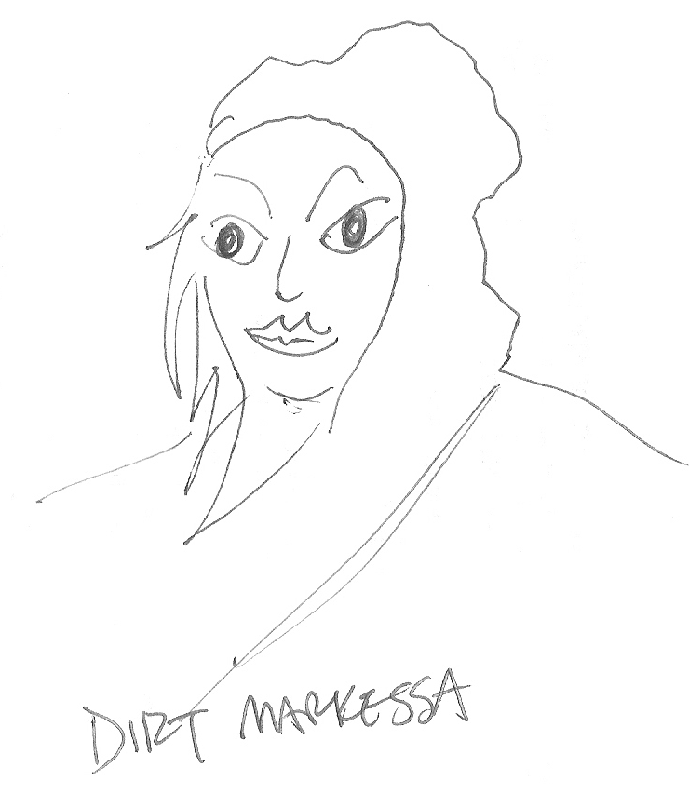
Once the goblins are defeated, the heroes release the dirty elf. She tells them her name is Dirt Markessa an that she is a ranger who travels the countryside in support of local farmers. She mourns the death of her dwarven companion, and then agrees to lead the group to her next destination, the nearby farming village of Donst.

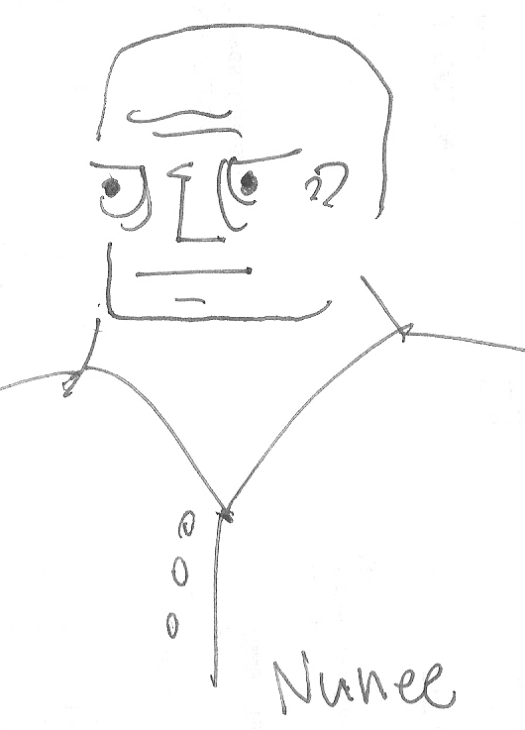
In Donst, the farmers are skeptical at first. The don’t have many visitors, and certainly not this many well-armed visitors. However, after giving the farmers the silver found on the slain goblins, Nunee the Donst spokesman offers the hand of his eldest daughter in marriage. None of the heroes take him up on the offer, but much ale is brought to Smack’Em and a nice barn is cleared out to make room.

July 31, 110 Donst

The next morning the heroes make their way to the Fuice family village to make their deals. Unfortunately, they find the entire place emptied of people and looted of easily transportable goods and treasures. There is significant evidence of hobgoblin attack, but the lack of dead bodies is curious. Eventually, the heroes determine that the goblins must have driven the Fuice family to the shore where they were abducted onto a ship. The heroes begin to suspect Fleeta of more than thieft of the Fuice goods. The Fuice temple, a sturdy and functional structure is left empty and mostly unmolested following the attack. The group decides to hole up in this building to spend the evening.

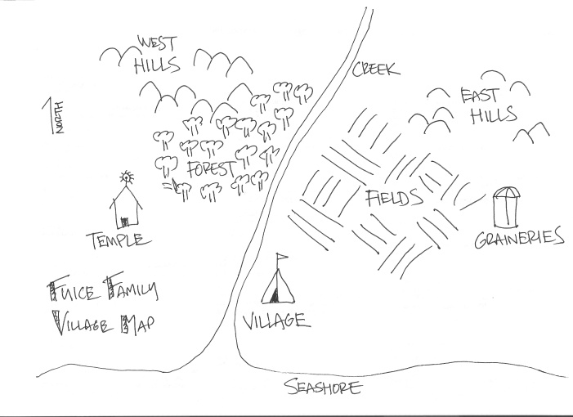

July 31, 110 Fuice
Just past midnight, Aramil heard a group of goblins approaching. Nearly a hundred goblins armed heavily in chainmail with heavy axes surrounded the door to the temple. The heroes briefly discussed sallying out to meet the goblins as they made their own preparations for assault, but the decision was made to dig in just inside the door of the temple.

The goblins break down the door with a makeshift ram created out of the heroes horsecart. Fafnir and Athelric fight just inside the right side of the door while Balasar and Nurz man the left side. Smack’Em and Aramil man barracades behind the front line and Dirk alternates between felling goblins with his sling and moving into backstab position.

The goblins do their best, throwing themselves through the door into the fray. At one point, it looks as though the goblins will break through when the goblin leader Zaagr starts blinding heroes and the goblin archers find the angle to start shooting through the door. However, the stout front line recomposes itself and redoubles its efforts to push the goblins back. Zaagr calls a general retreat leaving a single goblin cutter left for Nurz to knock unconscious. The heroes win the struggle, and loot the bodies of the goblins. A huge haul of second-hand chainmail and gold coins makes the struggle worthwile.

Aug 1, 110 Bad Moon Goblin Lair
The next morning, the heroes question their unconscious goblin. They find his name is Grongo (pronounced: GRONGO!!!!!), and through some creative questioning by Balasar, they learn all sorts of things about the goblin raid. Grongo tells the heroes that he belongs to the Bad Moon Tribe. He says that his tribe was commissoned by none other than a “dirty elf woman”, along with her dwarf and gnome companions to make a raid on Fuice. In exchange for the raid, the goblins got the advanced weaponry as well as a bunch of gold for each of them. Grongo offers to lead the heroes to his tribe’s cave in exchange for his life.

As the heroes near the Bad Moon Cave, Grongo calls out with a super secret code (“Grongo here! Don’t shoot!) allowing the heroes to parlay. Zaagr and two of his bugbear henchmen parlay with Athelric, Nurz, and Balazar. In exchange for 80 gold, Zaagr reveals that the “dirty elf woman” has hired the tribe to also drive the Donst family to the sea that very evening. Zaagr gives his word that the Bad Moon Tribe will not be there.

Aug 1, 110 Donst

The heroes arrive in Donst just at nightfall. They begin making preparations for the defense of the village including a sweep of a nearby stand of trees. While sneaking through that forest, Dirk and Aramil happen to encounter Dirt Markessa sitting with her back to them in the forest awaiting the goblins. Rather than take her out with their surprise there, they return for the group who charge Markessa and easily subdue her. They learn from Dirt Markessa that the slavers will come for Donst when the moon rises, and refuses to reveal (or can’t reveal) who has hired her for this dark duty of scouting farming villages for enslavement. Athelric strings her up by a rope and lets her hang until she dies. The heroes notice subtle burns and scars across her entire body, suggesting that perhaps she had felt the work of a skilled torturer in the past.

Aramil dresses up as Markessa and waits on the beach to meet the slavers. A red-haired elven woman arrives in a longboat commanding seven slavers. They almost immediately determine that Aramil is not Dirt Markess and they suspect the trap. They turn back into the sea. However, the determination of the adventurers make escape impossible. Aramil teleports into the boat, while the dragonborn swim out to take the fight to the slavers. The elven wizard woman, a duplicate of Dirt Markessa in features but not coloring, nearly escapes by summoning a demon and swimming out to sea. However, the heroes ferocity is undaunted and they eventually capture this second Markessa easily.

Aug 4,110 Irongate
The heroes are unable to learn much from “Red Markessa”, so they return to Irongate with their captive and story to claim their reward from Aishia.

