THE DEADLY FERRETS

**The Principals:**

Captain Fortunato: man, fighting-man, level 2, neutral, AC 4, Hp 11, move 90

Str 10, Int 7, Wis 11, Dex 10, Con 11, Cha 15

chain, shield, sword, dagger, mace

Fergus, man, fighting-man, level 1, neutral, AC 4, Hp 4, Move 90

Str 13, Int 8, Wis 12, Dex 10, Con 13, Cha 10

chain, shield, sword, dagger, light crossbow, quiver with 30 bolts

Morkar, man, magic-user (learned), level 1, neutral, AC 9, Hp 4, Move 120

Str 10, Int 15, Wis 9, Dex 10, Con 12, Cha 14

robes, dagger x2, quiver 12 darts, spellbook, 6 torches, tinderbox, bandoleer 3 oil

Spells in Book: (1): Read Magic, Detect Magic, Sleep, Charm Person, Analyze, Light, Shield

(2)Invisibility; (3): Clairvoyance, Fireball, Hold Person, Protection from Evil 10’

Gnarley, gnome, scout/magic-user (empowered), level 1, neutral, AC 9, Hp 4, Move 90

Str 9, Int 12, Wis 8, Dex 15, Con 15, Cha 15 (Initiate of Master of Waters)

clothes, shortbow, quiver 20 arrows, sword, dagger, tool kit, bandoleer 3 oil, Sleep Spell 1/day

Errando, wood-elf, druid/scout, level-1, neutral, AC 7, Hp 6, Move 120

Str 7, Int 8, Wis 16, Dex 15, Con 5, Cha 9 (Initiate of Mistress of Flame)

leather, mistletoe, spear, tool kit, sling and 20 stones, dagger 3x level 1 spells/day

Snake, man, scout, level 1, neutral, AC 7, Hp 5, Move 120

Str 10, Int 5, Wis 10, Dex 15, Con 11, Cha 15 (initiate of Mistress of Flame)

leather, shortbow, quiver 20 arrows, tool kit, dagger

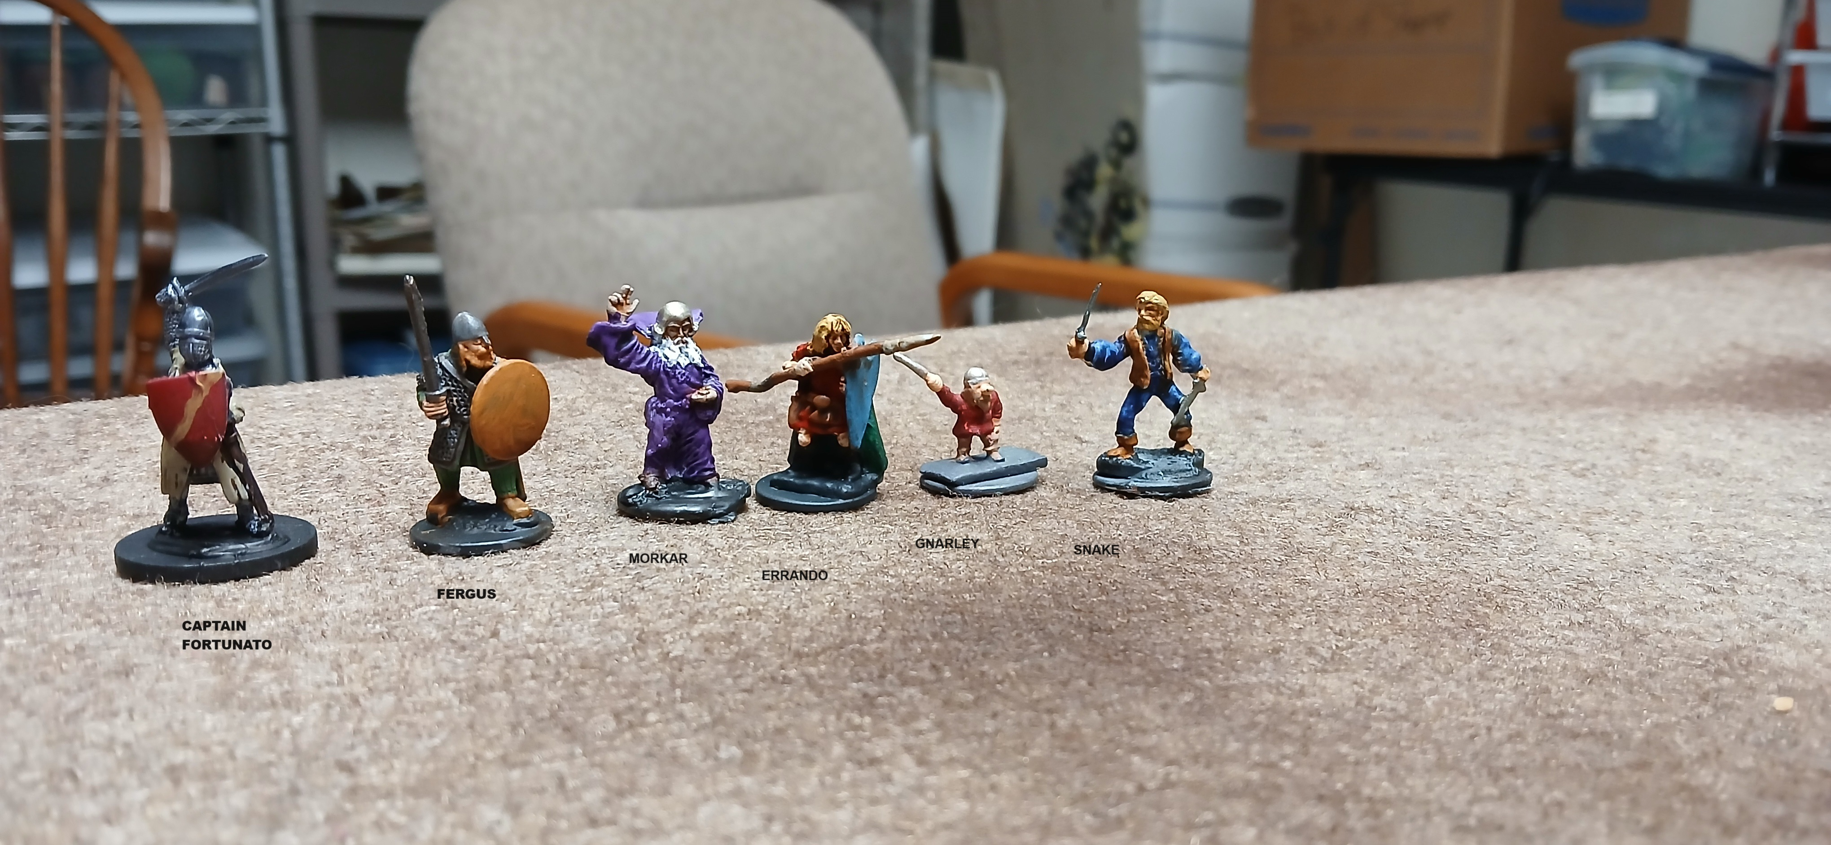

**Bandits x5: Squad A**

Experienced, +0 Morale, +0 to hit, AC 6, Move 120

Leather, shield, hand ax, spear

Andy Hp 5, Arnold Hp 6, Alvin Hp 4, Abe Hp 5, Angus Hp 3

**Bandits x5: Squad B**

Experienced, +0 Morale, +0 to hit, AC 6, Move 120

Leather, shield, hand ax, spear

Bill Hp 4, Bob Hp 3, Bear Hp 1, Bunt Hp 2, Bugs Hp 5

**Dogsbodies x4**

Green/Untrained, -2 Morale, -2 to hit, AC 9, Move 120

Club, torches, tinder box

Doug Hp 4, Dave Hp 5, Dan Hp 1, Dill Hp 2

**Mules x3**

Ac 7, HD 2, Move 120’

Pack Saddles: hold 2000 wt, mules can carry total of 3000 before half move.

Mule 1: Hp 8: 4 large sacks, 50’ rope, crowbar

Mule 2: Hp 7: 3 flasks oil, 50’ rope, 3 small sacks

Mule 3: Hp 12: shuttered lantern, 4 flasks oil, 10 wax candles.