Session/Game: Deadly Ferrets, Starkpool OD&D 1 Date: August 25-26, 2024
Episode 1: The Turnipville Raid
Campaign Date: September 1-4 YN 1024

The Principals:
Captain Fortunato: man, fighting-man, level 2, neutral
Fergus, man, fighting-man, level 1, neutral
Morkar, man, magic-user (learned), level 1, neutral
Gnarley, gnome, scout/magic-user (empowered), level 1, neutral
Errando, wood-elf, druid/scout, level-1, neutral
Snake, man, scout, level 1, neutral
The Bandits:
Bandits x5: Squad A
Experienced
Andy Hp 5, Arnold Hp 6, Alvin Hp 4, Abe Hp 5, Angus Hp 3
Bandits x5: Squad B
Experienced
Bill Hp 4, Bob Hp 3, Bear Hp 1, Bunt Hp 2, Bugs Hp 5
Dogsbodies x4
Green/Untrained
Doug Hp 4, Dave Hp 5, Dan Hp 1, Dill Hp 2
Mules x3

Judge: Dave N. (Solo/Test Game)

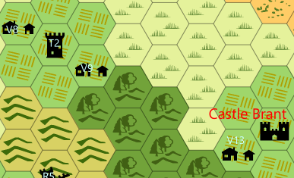

Background:
Having used most of his own and the principals’ cash to outfit the company, Captain Fortunato needs to make a successful raid to meet his expenses and reward his men. His target is the farming village of Turnipville (V9), which has a population of 800 and thus a militia of up to 160 farmers. The captain doesn’t know whether there is a garrison of professional troops or not, but the village is uncomfortably close to a small castle called Tower Menace (T2). He has enough food to feed the expedition for 3 days (mostly carried on the mules). The plan is to leave their home base in West Brantley (V13) and take 1 day to cross 3 hexes of open country, then enter the wooded hills and emerge at the target (V9) at nightfall on the 2nd day. They will raid the village, taking food and valuables and escaping before serious opposition appears.

Day 1: September 1, 1024, Cross Country:
The company neither gets lost nor has an encounter. They use 20 man/days of food.

Day 2: September 2. 1024, Open grassland to Wooded Hills:
The company does not get lost. They do not have an encounter. They use 20 man/days of food.
Evening of Day 2. September 2, 1024. Village of Turnipville.
Captain Fortunato sends Gnarley, Snake and Errando to scout the edge of the village. They enter from the south east onto Grain Street. The section they spy has 7 farmer’s cottages, one larger house and a pair of grain storage buildings.

Grain Street, Turnipville

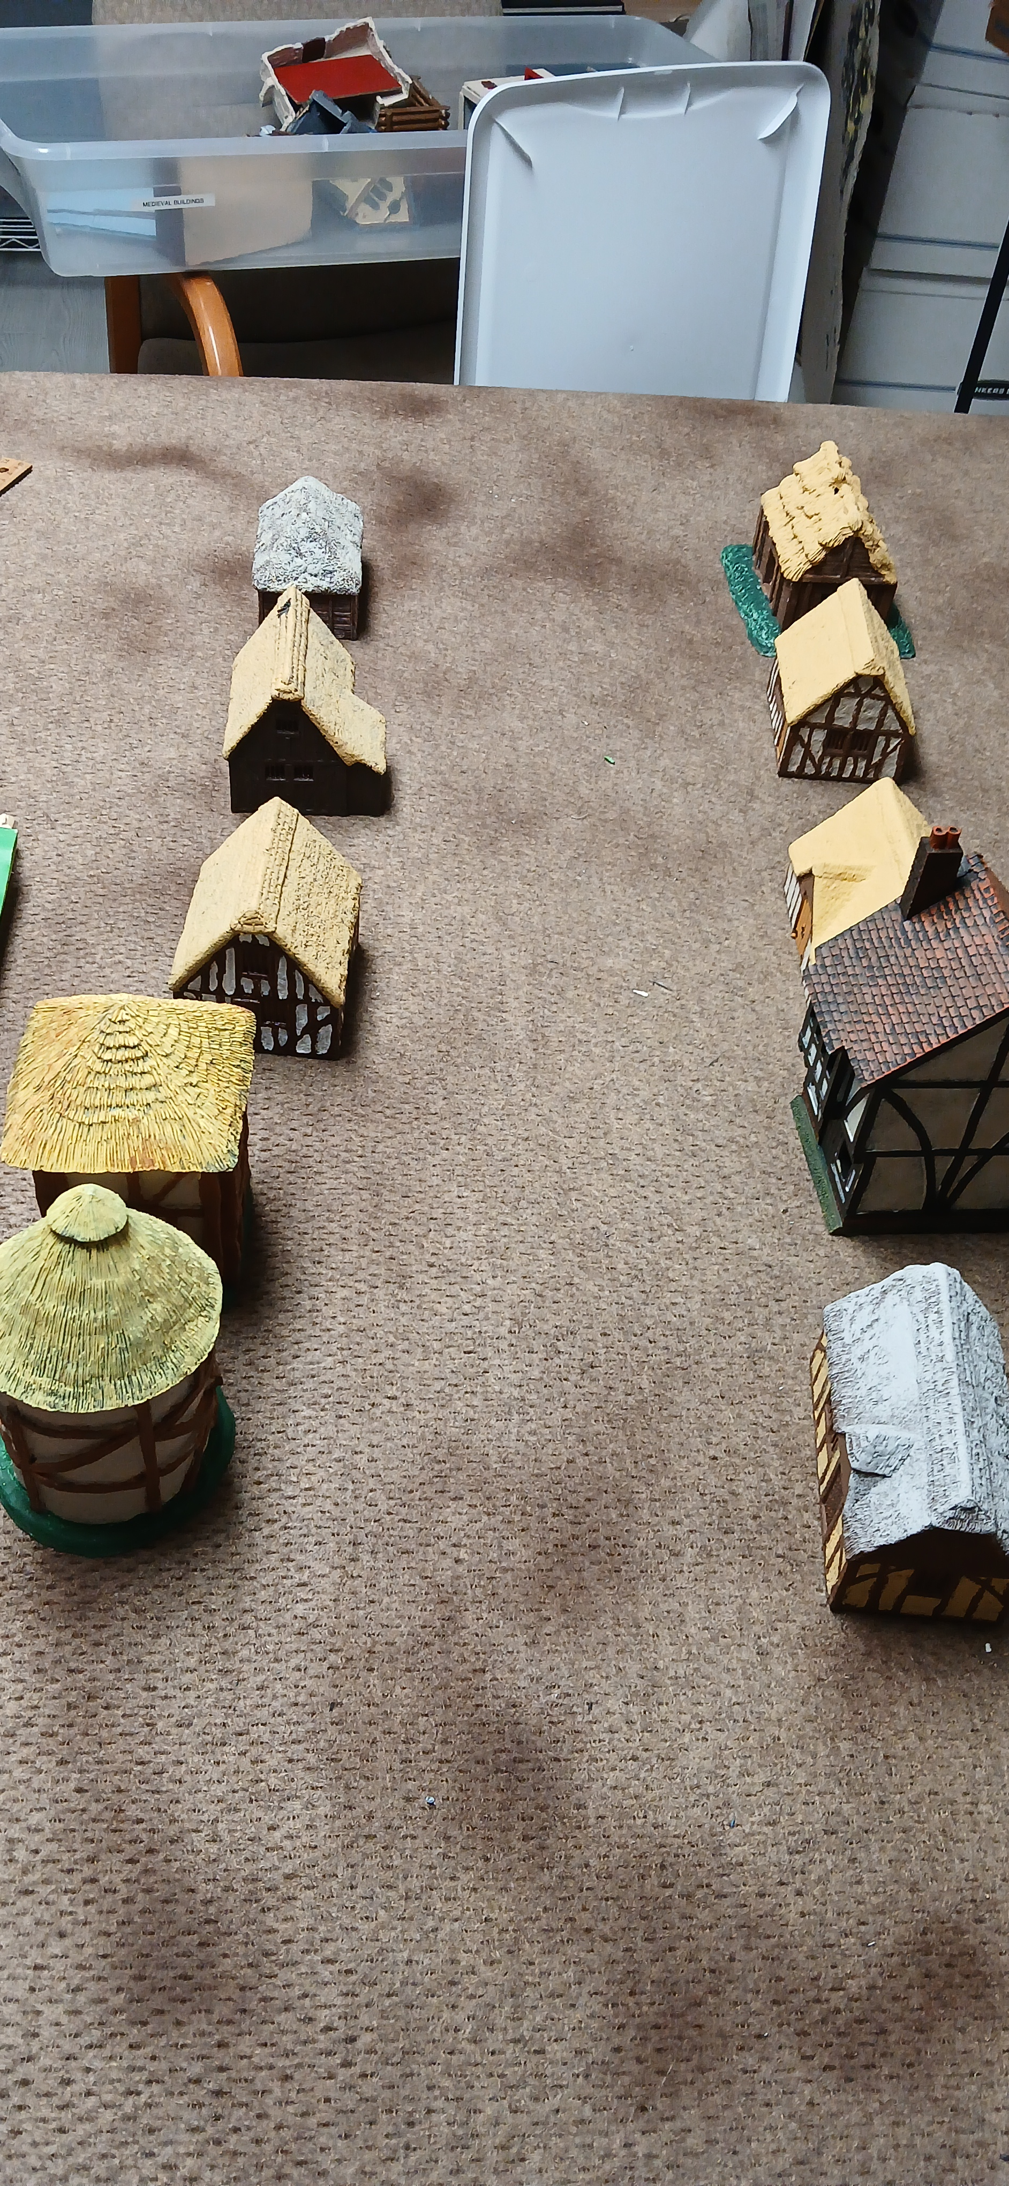

As the sun sets they sneak down the street hoping to discover whether there is a professional garrison, or only farmer-militia. They go to the large house, and discover it is the house of the village reeve. They explore the street for 2 turns and discover that there is no garrison building nor signs of their presence. On the second turn they run into a group of peasants heading down the street, but manage to surprise them and slip away unnoticed.

Gnaley, Errando and Snake avoid the peasants.

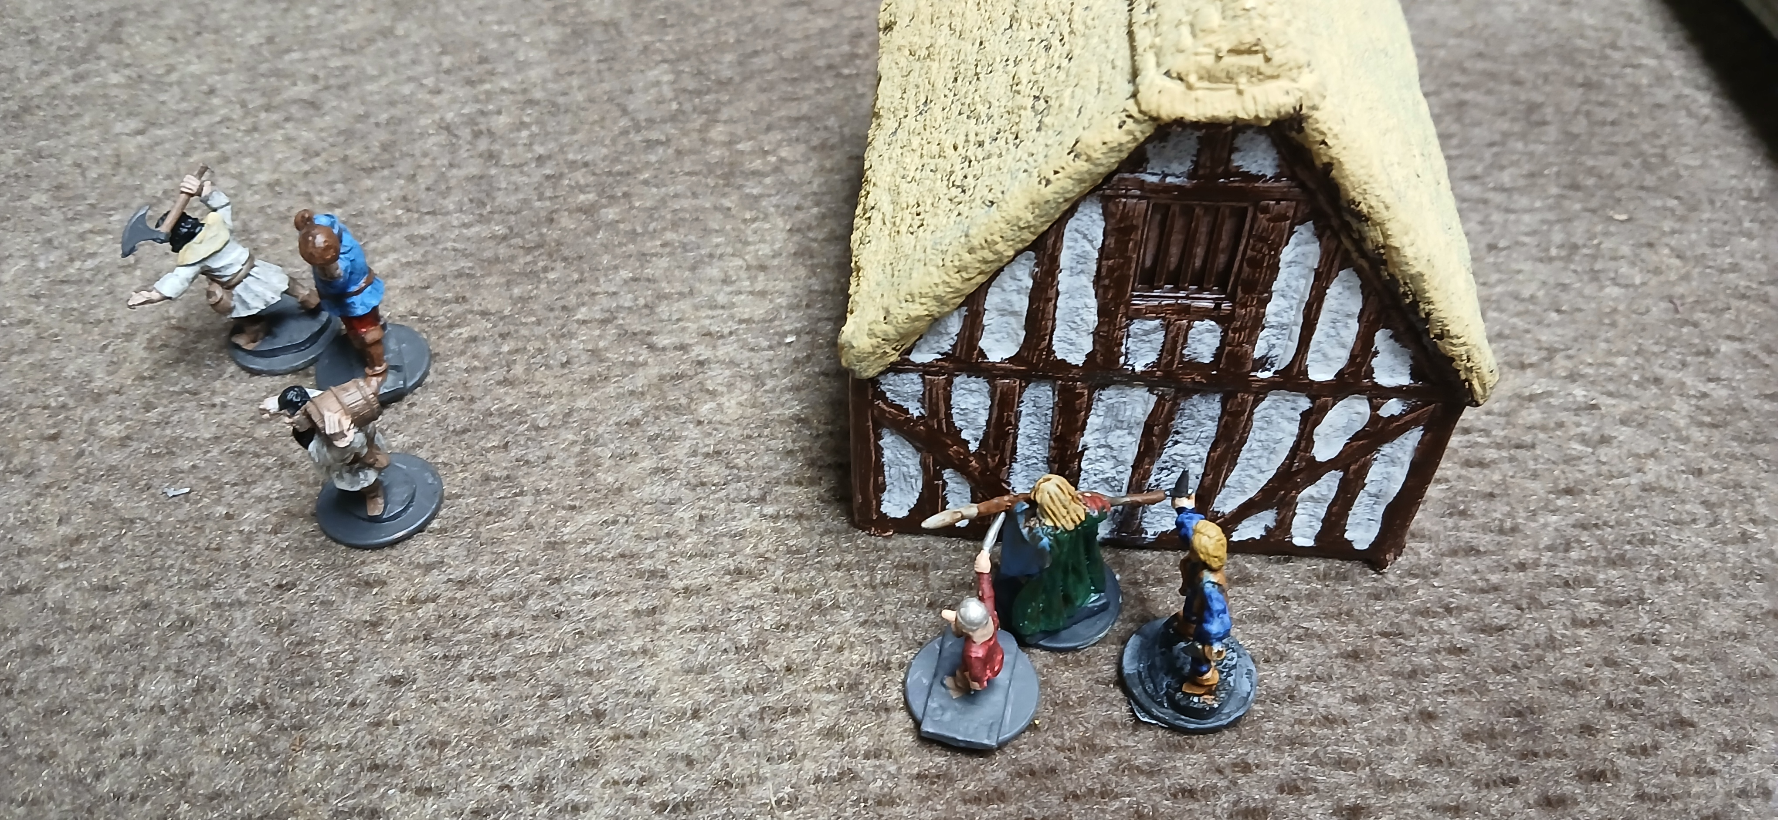

The scouts return to the captain and he decides that they will quickly raid this street. The 10 footmen and 2 of the dogsbodies will split into 4 teams and each team will sack one house. The Captain, Gnarley and one dogsbody will loot the Reeve’s house. The last dogsbody, Fergus and Errando will take 2 mules and loot the grain buildings. Morak and Snake will act as the trouble-reaction team.
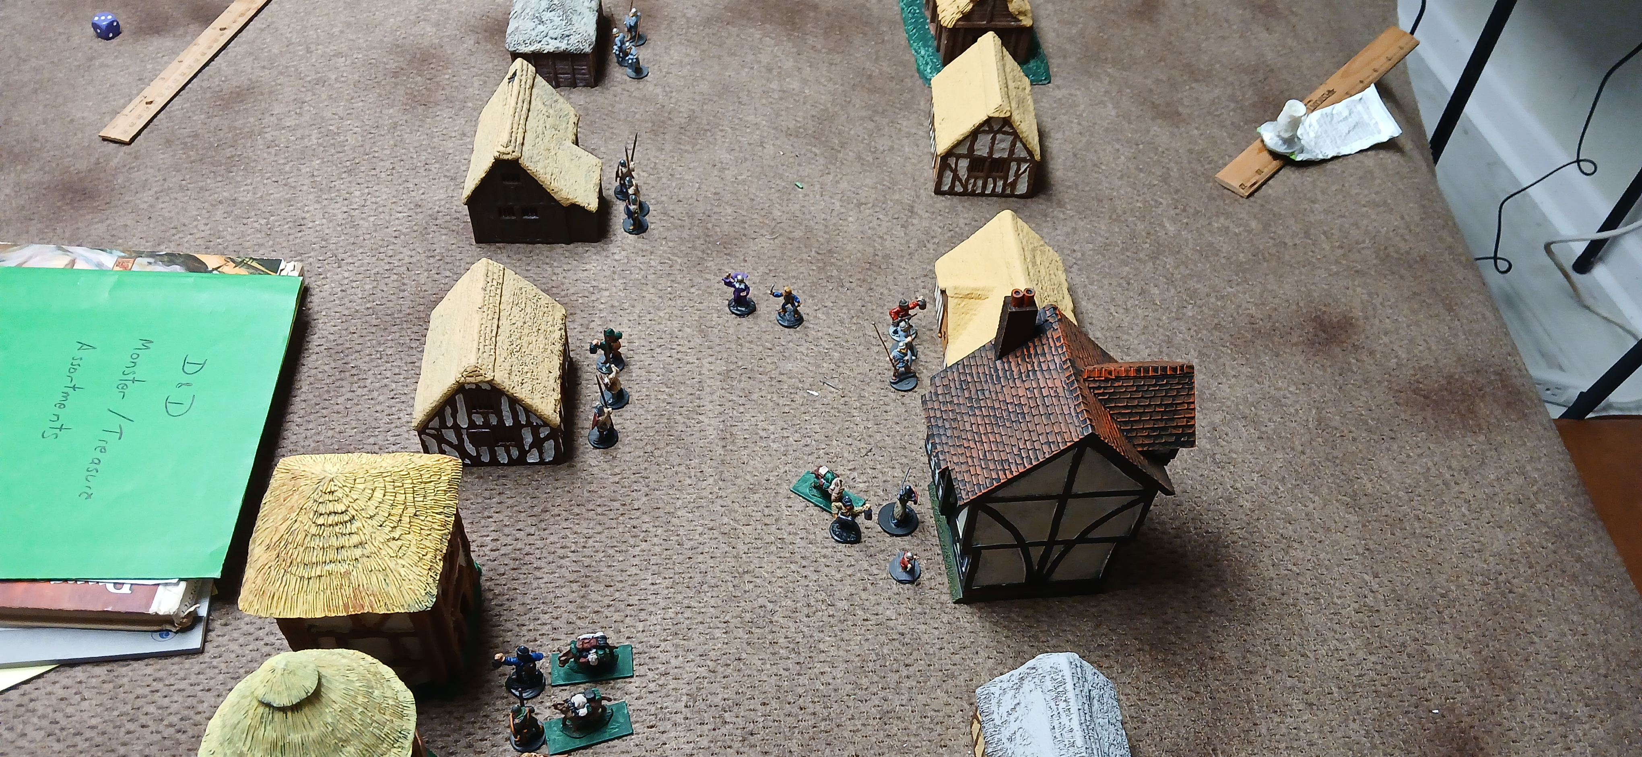

Peasants: AC 9, Hp 1d6, -2 to hit, -2 morale, club
Militia: AC 6, Hp 1d6, -1 to hit, -1 morale, spear

Turn 1
A--Fortunato, Gnarley and D.B. Doug—Reeve’s house. 7 peasants inside, who immediately flee. The very next round, 3 militia will enter the building. (AC 6, Hp 6,3,2, -1 morale, -1 to hit, spears).
B—Errando, Fergus, D.B Dave—Granaries. 6 militia are milling about on guard but they immediately flee, raising the alarm. While 3 of the militia disperse to raise the alarm, 3 of the militia rally and begin to return to the granaries, arriving on round 4.
C—Andy, Arnold and D.B. Dan—cottage. 3 peasants who decide to fight fiercely. 2 more militia will arrive on round 5.
D—Bill, Bob, D.B.Dill—cottage. 3 peasants who decide to fight fiercely. 5 militia will arrive on round 3.
E—Bear, Bunt, Bugs—cottage. 6 peasants who decide to fight fiercely. Large militia force will arrive on round 6.
F—Alvin, Abe and Angus—Cottage. 2 peasants who flee immediately, no event.

Round 2:
A—Initiative: Company wins, choose move
Move: Captain Fortunato closes with militia in front of Gnarley, but doesn’t charge. Doug stays in the street. Gnarley stays behind Fortunato
Counter Move: the one militia who wasn’t locked in melee closes with Fortunato.
Missile Phase: None
Melee: Spears have longer length than sword, so militia strike first, needing 16+. All three miss. Fortunato is 2nd level so gets 2 attacks vs the militia, plus one more since his sword is 4 length shorter than their spears. He needs a 13 and misses them all. He damages his sword in the process.
B— (more Round 4)
First round of looting
C—(more Round 5)
Initiative: Peasants win choose move
Move: peasants rush the bandits.
Counter-Move: all are locked
Missile: None
Melee: The spear-bandits attack first, then the peasants, then Dogsbody. One peasant is killed by Andy. Peasants need to check morale, but pass. Peasant 1 natural 20 on Arnold, doing 5 points of damage, Arnold has 6 so is still in the fight. Peasant 2 hits D.B Dan for 1, but that’s all he had so Dan’s dead.
D— (more round 3)
Initiative: Company wins, chooses move
Move: Bill and Bob charge the peasants, Dill advances carefully.
Counter Move: all are locked in melee
Missile Phase: none
Melee: Bill and Bob go first as they have spears vs clubs. Needing 13, getting +1 for charge. Both hit, 2 kills. The third peasant clubs Dill needing a 10 and hits and drops him. This last peasant fails morale and flees.
E—(More Round 6)
Initiative: 6 Peasants surprised!
Move: Bandits rush in
Missile: None:
Melee: Bandits attack by surprise. Spear vs AC9 is 10+, add +1 for charge and +2 for rear attack. 2 peasants are killed. The peasants must make a morale check, 8+, but they roll a 6 and flee.
F—First Round of looting

Round 3:
A—Initiative: Militia wins, choose move
Move: All locked
Counter Move: D.B. Doug and his mule flees toward the edge of town. Gnarley executes a Split-shot, going into the street, shooting at the militiaman who just killed Morkar (see melee D below), missing but keeps moving around the corner of the building, out of sight.
Missile Phase: None
Melee: Captain Fortunato again gets three attacks vs the militiamen, needing a 13 -1 for damaged sword. He hits all three, kills 2 and wounding the third, who fails morale and flees, but Fortunato gets a free Rear Attack against him, hitting him for 4 more, killing him. RAMPAGE!
B— (more Round 4)
Second round of looting
C—(more Round 5)
Initiative: No moves
Move: None
Counter-Move: None
Missile: None
Melee: Peasants attack first with clubs, needing 14 with a -2. One hits, one misses. Andy takes a hit for 1 and still is in the fight. Andy and Arnold attack, needing 10’s. Arnold hits but only wounds his enemy (3/6).
D— 5 Militia Arrive coming around south end of house, right in front of Morkar and Snake, who join this melee.
Initiative: Militia Wins, choose Move
Move: Three militia enter house, 2 rush Morkar and Snake. Snake makes a Pass-Through Shot, 13+, +1, misses with a 7.
Counter Move: All the Ferrets locked in melee
Missile Phase: None
Melee: Snake and Morkar attempt to Refuse Melee. Snake needs 13- on d20, rolls a 4 and escapes. Morkar needs 12-, rolls a 14 and fails. Militia all attack first. #1 needs 10+ to hit Morkar, rolls Natural 20, does 8 points of damage, dropping Morkar. #2, #3,#4 need 13 to hit Bill and Bob. Bill is hit for 8 and killed. Bob is hit for 4 and killed.
E—(More Round 6)
First Round of Looting
F—Second Round of looting

Round 4:
A—Three militia arrive at end of street (heading for granaries).
Initiative: Militia win, choose Move
Move: Militia move toward the granaries.
Counter-Move: Fortunato comes to meet them, but they aren’t quite close enough, Gnarley does not surprise them, lurking in shadows. He does not move. Doug and his mule continue to head out toward the rally-point in the wooded hills, almost reaching edge of table.
Missile Phase: Gnarley shoots 2 arrows. He needs 13 getting a +1 for Dex. One hits, but only wounds the guy (4/6).
B—3 Militia arrive at end of street, but Gnarley and Fortunato will deal with them.
Third Round of Looting: They manage to find a cash box with 700sp and 25 man/days of basic food.
C—(more Round 5)
Initiative: No moves
Move: None
Counter-Move: None
Missile: None
Melee: Peasants attack first with clubs, needing 14 with a -2. One hits and kills Arnold. Andy attacks needing 10. He rolls 9 and misses. Andy passes his morale roll and keeps fighting.
D— Initiative: Company wins, chooses Move
Move: Snake moves back around the corner of a house and shoots 1 Split-shot arrow. He needs 13, +1 Dex, but misses and keeps moving.
Counter Move: The 5 militia form up and head toward the 2 teams of bandits to the south.
Missile Phase: None
Melee: None
E—(More Round 6)
Second Round of Looting
F—Third Round of looting recover 10 days of horse grain.

Round 5:
A—Initiative: Ferrets win, choose Move
Move: Fortunato does not charge, but simply moves to contact with the 3 militia. Gnarley tries a Split-Move Shot and hits a militiaman, killing him. The militia pass the morale check.
Counter-Move: Militia are locked
Missile Phase: None
Melee Phase: the 2 militia with spears attack Fortunato first, needing 16 with -1. Both miss. Fortunato gets 3 attacks against them, needing 13+, -1 for damaged weapon. He hits twice, killing them both.
B—Errando and Fergus join Fortunato
C—2 militia enter from the back of the house.
Initiative: Villagers win, choose move.
Move: 2 militia join peasants in beating on Andy.
Counter-Move: None
Missile: None
Melee: Peasants attack first with clubs, needing 14 with a -2. One hits and kills Andy.
D— Initiative: Company wins, chooses Move
Move: Snake achieves surprise from his hiding place. Doug does not move
Counter Move: The 5 militia move after Doug and his mule but don’t catch him
Missile Phase: Snake makes 2 surprise arrow shots at the militia. He needs a 13, with a +4 for surprise attack and +1 for Dex. He hits once, killing one militia man.
Melee: None
E—(More Round 6)
Third Round of Looting: find nothing.
F—Alvin, Abe and Angus come out of the cottage and attack the 4 militiamen in the street. Straight to melee.
Melee: Bandits attack first as attackers with same weapons. They need 13+. Abe hits and kills 1 militia. This causes a morale check which passes. The militia need 13+, with a -1. All miss.

Round 6:
At this point a large band of v40 villagers appear at the north end of the map, half equipped as militia, half as peasants. The other 2 forces are the 2 peasants and 2 militia in house C, and the 3 militia at the south end of the road engaged with Angus, Abe and Alvin. This will be consolidated into 1 melee. Hmm, Morkar’s sleep spell would be really handy now.
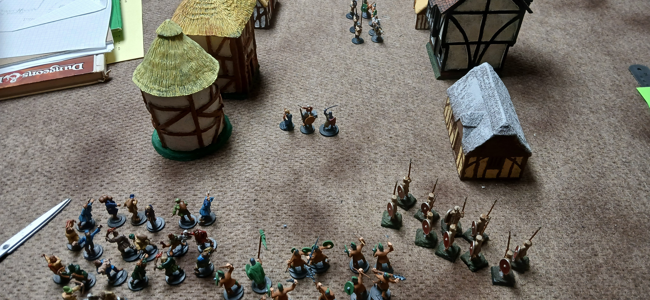

Initiative: Ferrets win, choose Move
Move: Errando, Fortunato, and Fergus line up facing the large force, Gnarley takes position in 2nd rank. Doug leaves town. Dave and his mules move behind the houses. Snake moves behind House C. Bear, Bunt and Bugs line up to receive the 2 militia/2 peasants from house C.
Counter-Move: Large force advances. 2+2 group meets B,B+B.
Missile Phase: Gnarley shoots 1 arrow at a peasant, but only wounds (2/4).
Melee: A,A+A attack 3 militia, scoring 1 hit only a wound (4/6). Militia counter-blows all miss. 2 militia and 2 peasants attack B,B+B. The militia miss, but one of the peasants scores a 20, doing 6 points killing Bear. Bunt and Bugs attack killing 1 militia, also with a 20. Both sides break morale and flee.

Round 7:
Initiative: Villagers win, choose Move.
Move: The small bands are locked in melee. The large force surges forward to contact Fortunato, Errando and Fergus. Errando shoots a sling as Pass-Through, but misses.
Counter-Move: Snake creeps behind the Reeve’s house.
Missile Phase: Gnarley casts Sleep Spell, dropping 5 militiamen from the squad not yet engaged. Snake achieves surprise and shoots 1 arrow at the same group. He hits for 8 points, killing one.
Melee: Abe, Alvin and Angus attack the 3 militia, making 2 hits, killing 2. The last must make a morale check and fails, fleeing but the free attacks fail. In the main press, 2 militia each attack Fortunato, Fergus and Errando. They need 16 with a -1, for F+F. They need 13, with a -1 for Errando. All of the militia miss. Errando may not attack since he used his sling. Fergus and Fortunato need 13, but Fortunato has a -1 for damaged sword. Fortunato gets 3 attacks (level 2 and 4 point shorter weapon) and Fergus gets 2 attacks (weapon). Fortunato hits twice, killing both. Fergus misses. Only 8 of the militia have gone down, 10 are needed for a morale check.

Round 8:
Initiative: Ferrets win, choose Move
Move: Abe’s crew rush up the street toward the brawl. Bunt and Bugs continue to flee. Dave and Mules ease toward end of town. Snake makes a half move to behind the corner of the last cottage to the north. Gnarley runs to the corner of the reeve’s house. Fergus and Fortunato stay put.
Counter-Move: the large force swarm around Fortunato, Fergus and Errando.
Missiles: Snake again surprises and gets a surprise shot, killing another. Because Gnarley moved more than half his move, he needs to roll 4+ on 1d6 to get off a shot, and he rolls a 4, but the shot is a miss.
Melee: Fortunato, Fergus and Errando, who draws a dagger, go first. Fortunato gets 3 attacks, Fergus 2, and Errando 2. Fortunato hits 2, killing 1 and wounding another. Fergus hits twice, killing twice. Errando misses twice. At this point, the Ferrets have killed 12 of the 40, more than 25% of green troops. They need a 7+ to pass morale, with a -1 for the militia and -2 for the peasants. They roll a 3 and the villagers begin to flee in panic, saving Fortunato, Fergus and Errando from almost certain death by the horde of surrounding militia. The battle is over.

Endgame:
Needing to get out of town relatively quickly, but needing some loot, Fortunato orders Abe and his bunch to loot the Reeve’s house. He then orders Dave and his mules to come back. And for everyone to gather up as many shields from dead or fled militia as they can. The reeve’s house had a cash box with 1100sp. They collected and hauled out 20 shields.

The Trip Home:
September 3, Mid-night to 6am, through the Wooded Hills.
They meet up with their men who had fled and do a quick examination of Morak’s body. He actually is still alive and is quickly bandaged. He must rest for at least 1 week before he gains 1 hit point. They throw him over a mule and head out. They manage to not get lost and to avoid the patrols from Tower Menace through the evening.

September 3, Daylight—Through the Clear
Exhausted, the company pushes through the clear toward their home. In their exhausted state they make some wrong turns and waste a lot of time ending up in the wooded hills again and encountering a large force of 230 bandits. Since the group is so large, the Ferrets have a 50% chance of evading them, which they do. They find a shady grove and collapse exhausted.

September 4—Dash
Still exhausted the Deadly Ferrets manage to rush across the plains to their home base in West Brantley.

The Butchers Bill:
Morkar—out of action through September 11, fully healed on September 15.
Dead Bandits: Bill, Bob, Bear, Arnold, Andy (5/10)
Dead Dogsbodies: Dan and Dill.

The take:
25 man/days of basic food, eaten on the way home.
10 mule/days of grain, eaten on the way home.
1800sp
20 shields, used, sell for 5gp each=100gp

Total GP take: 280gp.
The Shares:
93 gp to Captain of which 31gp goes to the Baron. 62 gp actual take.
5 shares: the 5 level 1 characters
2.5 shares: the 5 remaining bandits
0.5 shares: the 2 remaining dogsbodies.
8 total shares of 187gp
23 gp per each level 1
12 per bandit
6 per dogsbody.

XP points:
Defeated approximately 60 peasants and militia=450 /6=75 xp per leveled character plus gold.

Hireling Loyalty Check and Advancement:
Squad A had a loyalty of 14, rolls a 16 and quits. Squad B had a loyalty of 17, roll a 10 and stays. The Dogsbodies had a loyalty of 10, and roll an 8 and stays. Squad B does not advance to Veterans (need 5-6, roll a 4). The dogsbodies must be trained to advance.

ANALYSIS:
Captain Fortunato made a bad plan and it would have ended in complete disaster if the large group pf villagers hadn’t failed the morale check on round 8. The take was small, but that’s because they were robbing small peasant farmers who are not famous for having loads of cash lying around. Attempting to rob 6 different buildings all at once seemed appealing in order to maximize the loot, but the peasants reacted unexpectedly fiercely, and the proportion of the response encounter was unexpectedly high (only a 1 in 36 chance of the Large Group responding, yet it did). Also, a smash and grab by 20 men against a village of 800, 160 of whom were militia wasn’t exactly brilliant.
A better plan would have been to use his scouts more effectively to stake out the more valuable targets, like the reeve’s house, and knock them off one at a time by stealth or overwhelming force. Or even better, look for wealthy merchants or the like to rob instead.
All in all, Fortunato was lucky to have only lost half of his bandits and dogsbodies and lucky again that Morkar wasn’t killed or permanently maimed by his wound. His next plan should be more judicious. Fortunato really should have changed to his mace after his sword was damaged.

GAME NOTES:
- Try not to roll separate initiative for each small group. Each melee is separate, but the other phases should all be run together.
- I should keep up the practice of letting Scouts who get out of sight to attempt to make a surprise roll at various times in the battle. Need to put that in the rules
- I did like the OD&D wilderness lost and encounter and evasion rules. They are way simpler than the AD&D ones. Might have to make the actual encounter tables fit the campaign area.
- 2nd level fighting-man in chain and shield with a sword was remarkably better than militia spear-men in leather and shield.

